**Step-by-Step Procedure to Install and Configure Jenkins (Ubuntu)**

**Step 1: Update Ubuntu Repository**

**In the terminal, update the system’s package index to ensure all packages are up to date:**

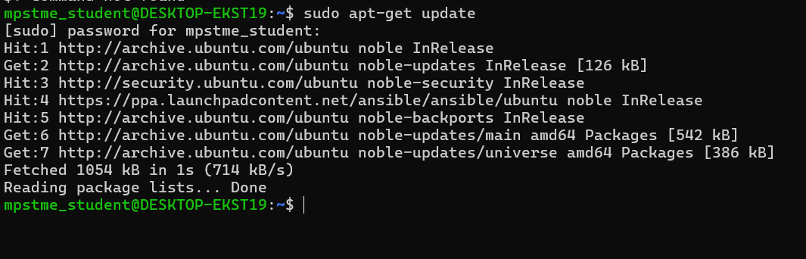

**Step 2: Install Java Development Kit (JDK)**

**Jenkins requires Java to run:**

**This will take a while to complete**

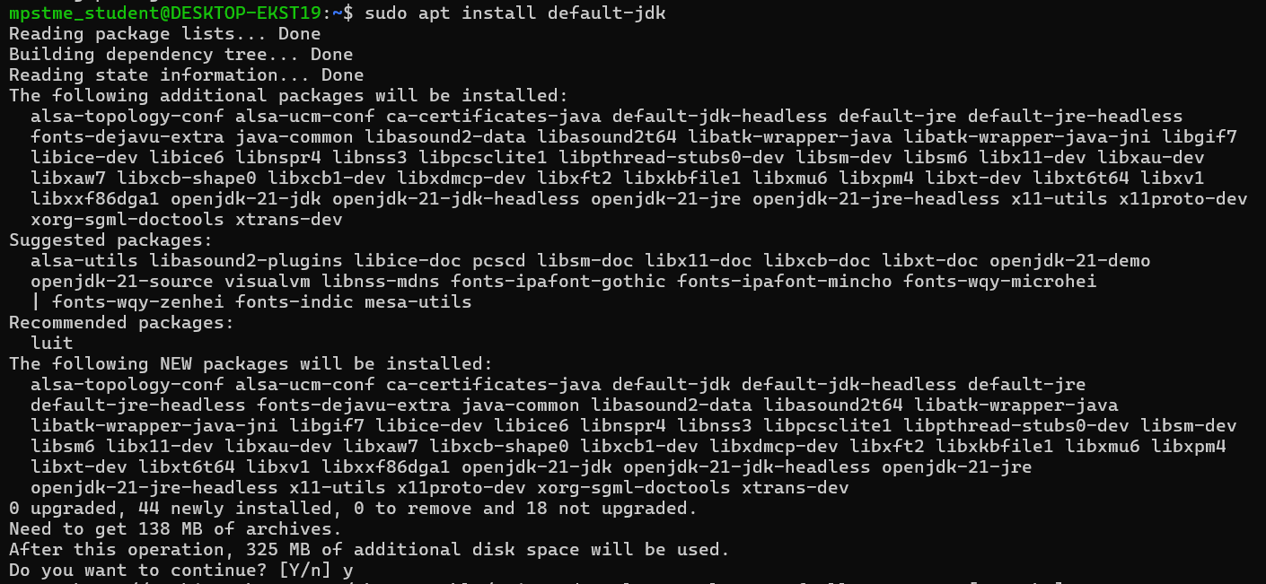

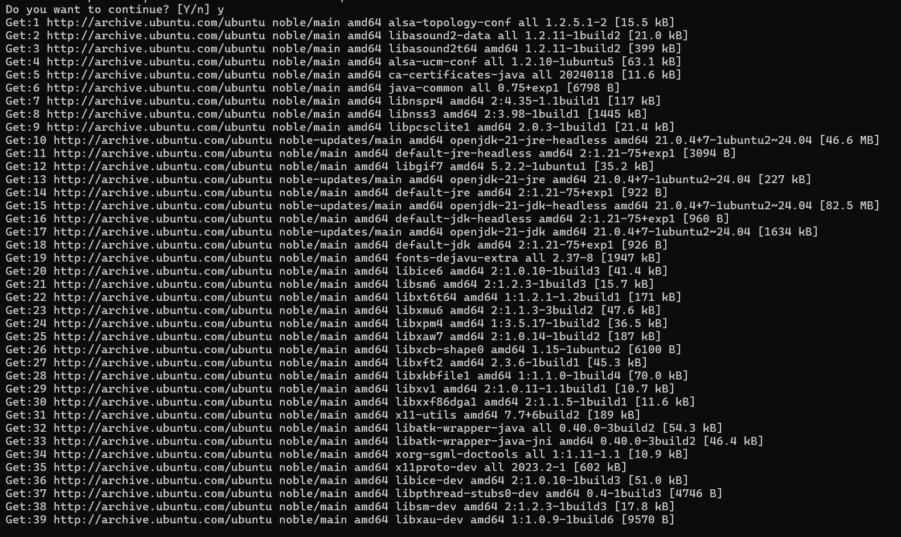

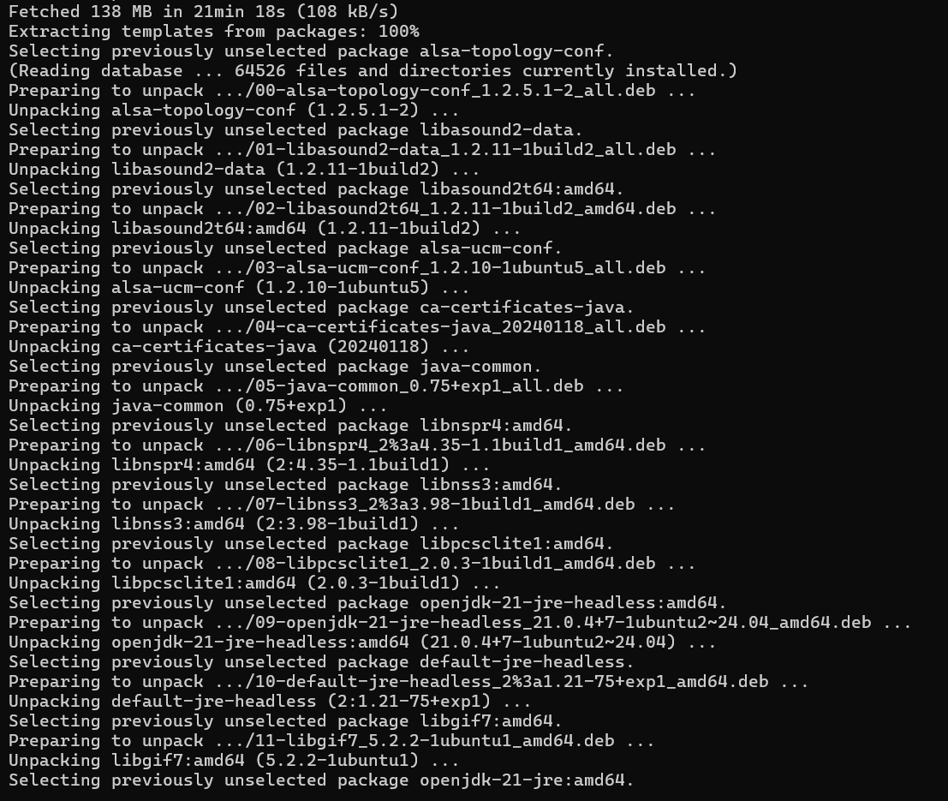

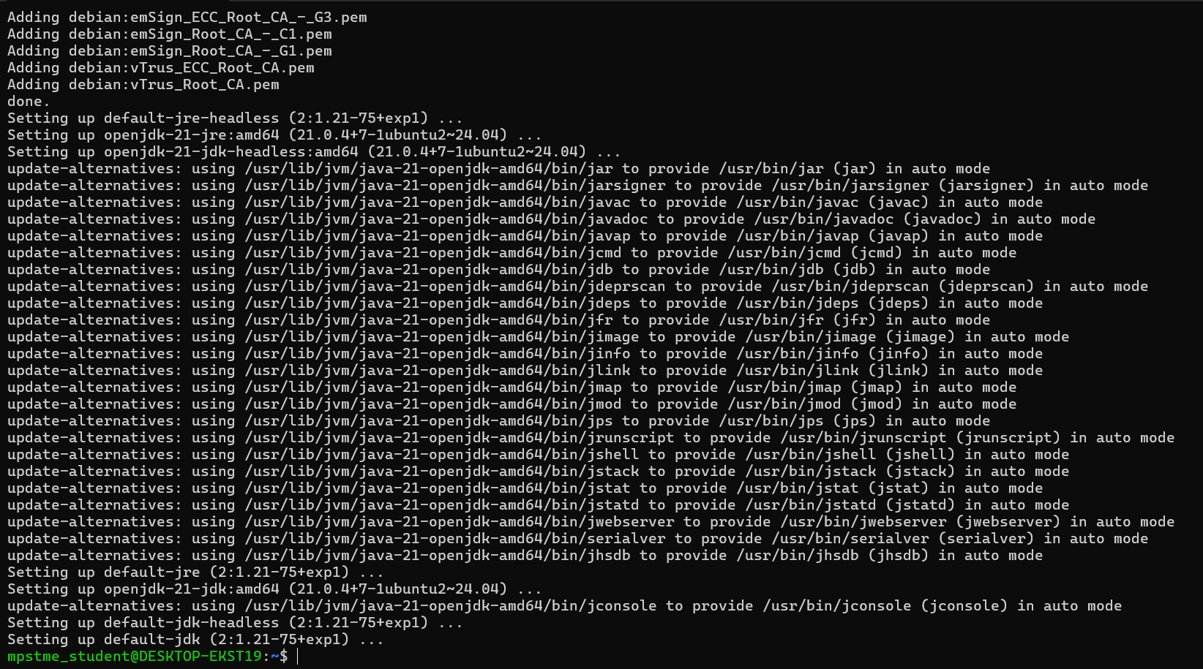

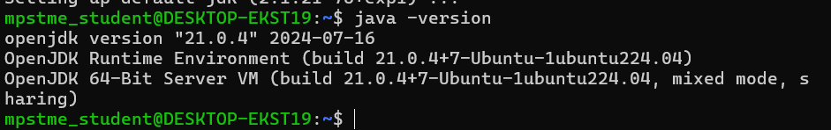

**Step3-: Download the latest jenkins.deb file from jenkins.io website by selecting ubuntu distribution.**

**Search Jenkins select the :**

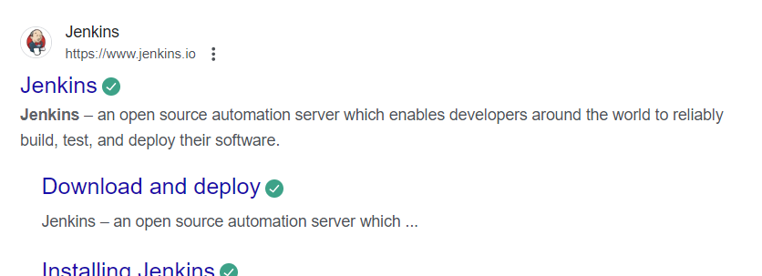

**Click on downloads:**

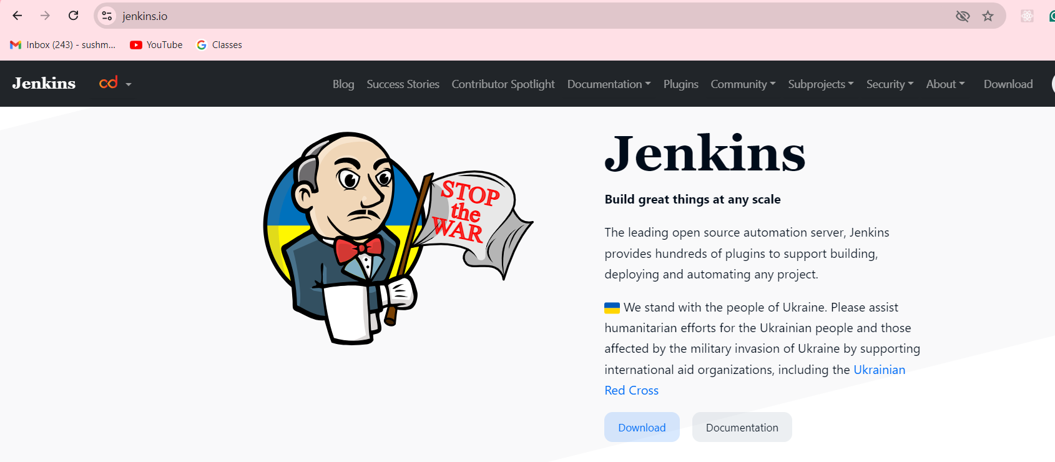

**Select ubuntu in LTS list(**Ensure you are under download Jenkins 2.462.3 LTS (long-term support) version**)**

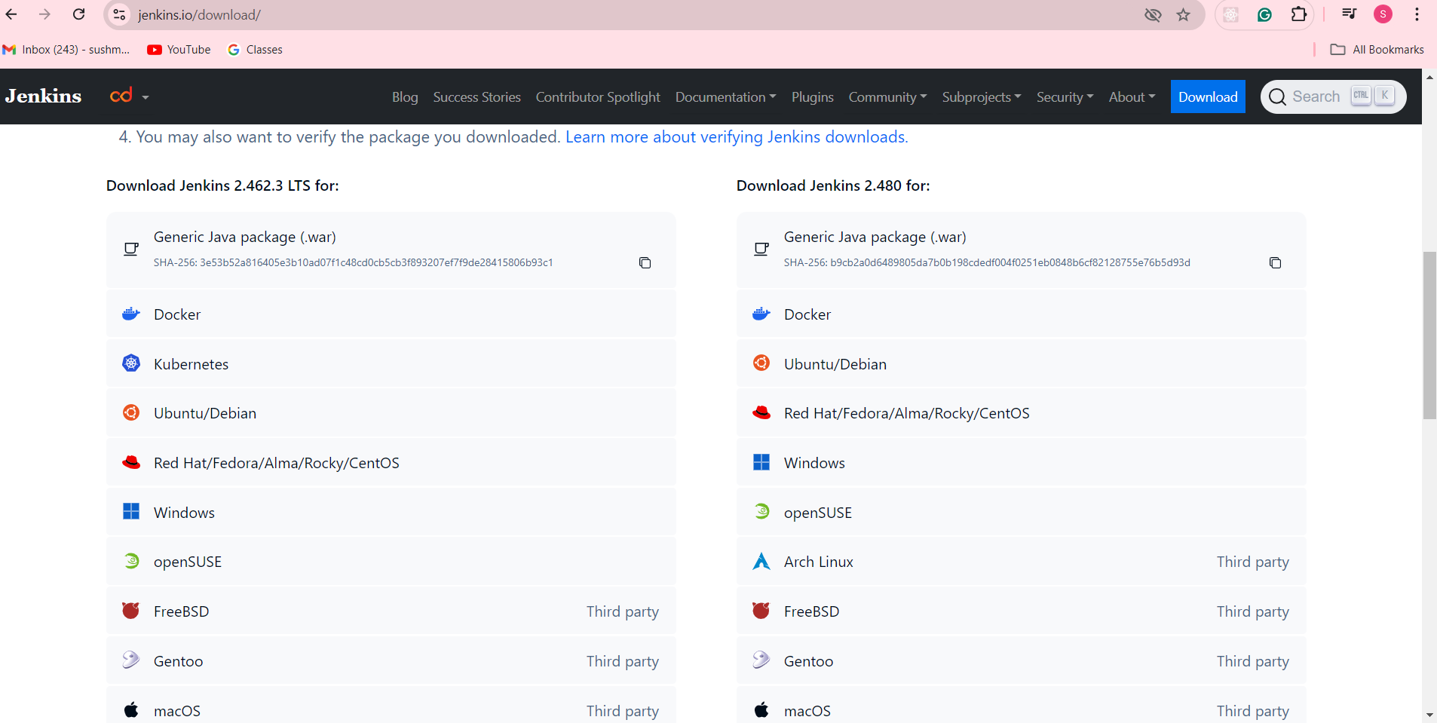

**Then the following page will appear where all commands will be given that needs to be run on ubuntu (which is done further )**

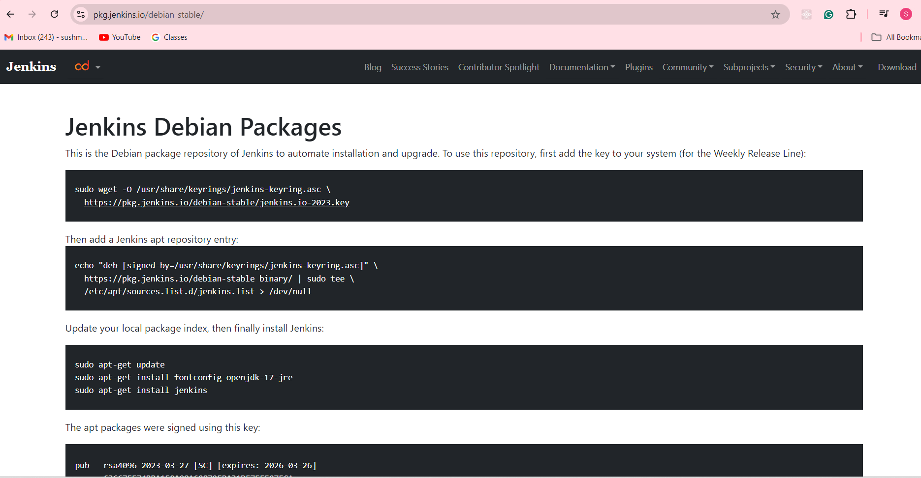

**This above page will appear after clicking Now one by one will run this command in our Ubuntu terminal as follows: (copy-paste one by one as given to the Ubuntu as I did below)**

**1st: **

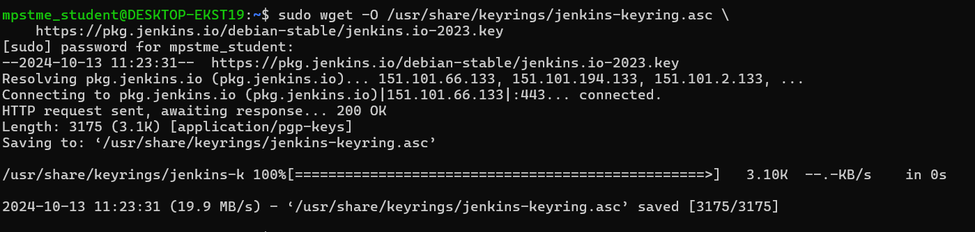

**2nd:**

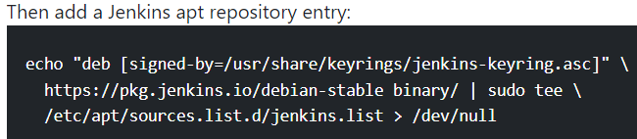



**3rd:**



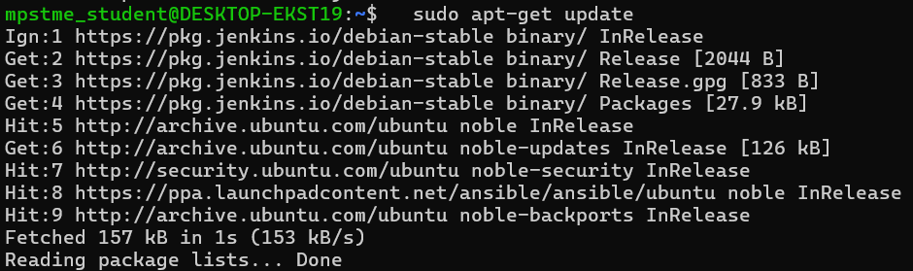

**4th:**

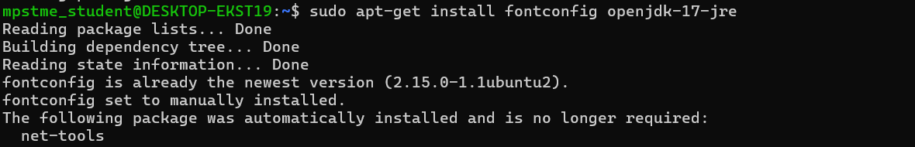

**5th:**

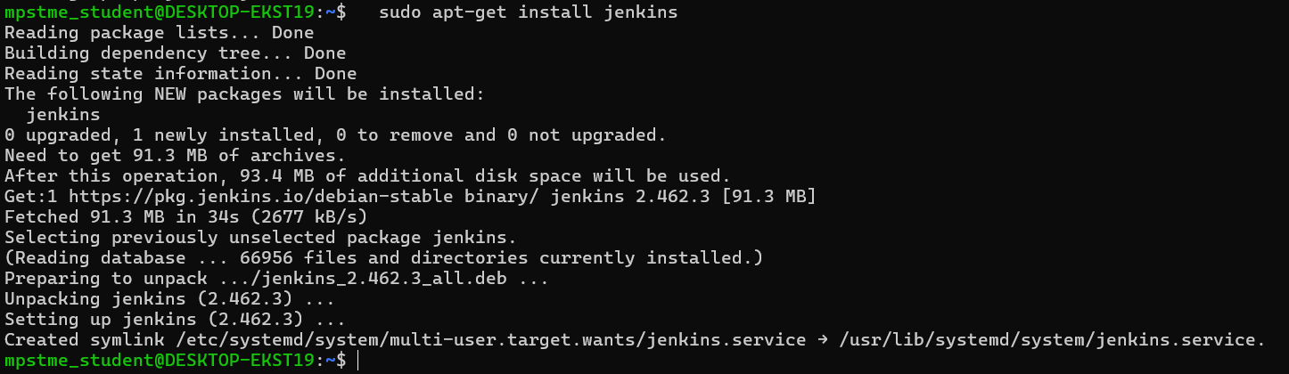

**Now check the status:**

**So now we can see our jenkin service is enabled and running**

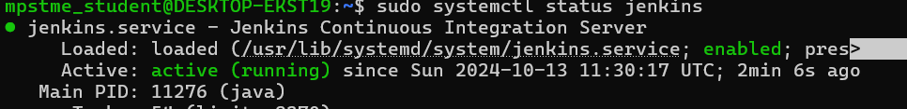

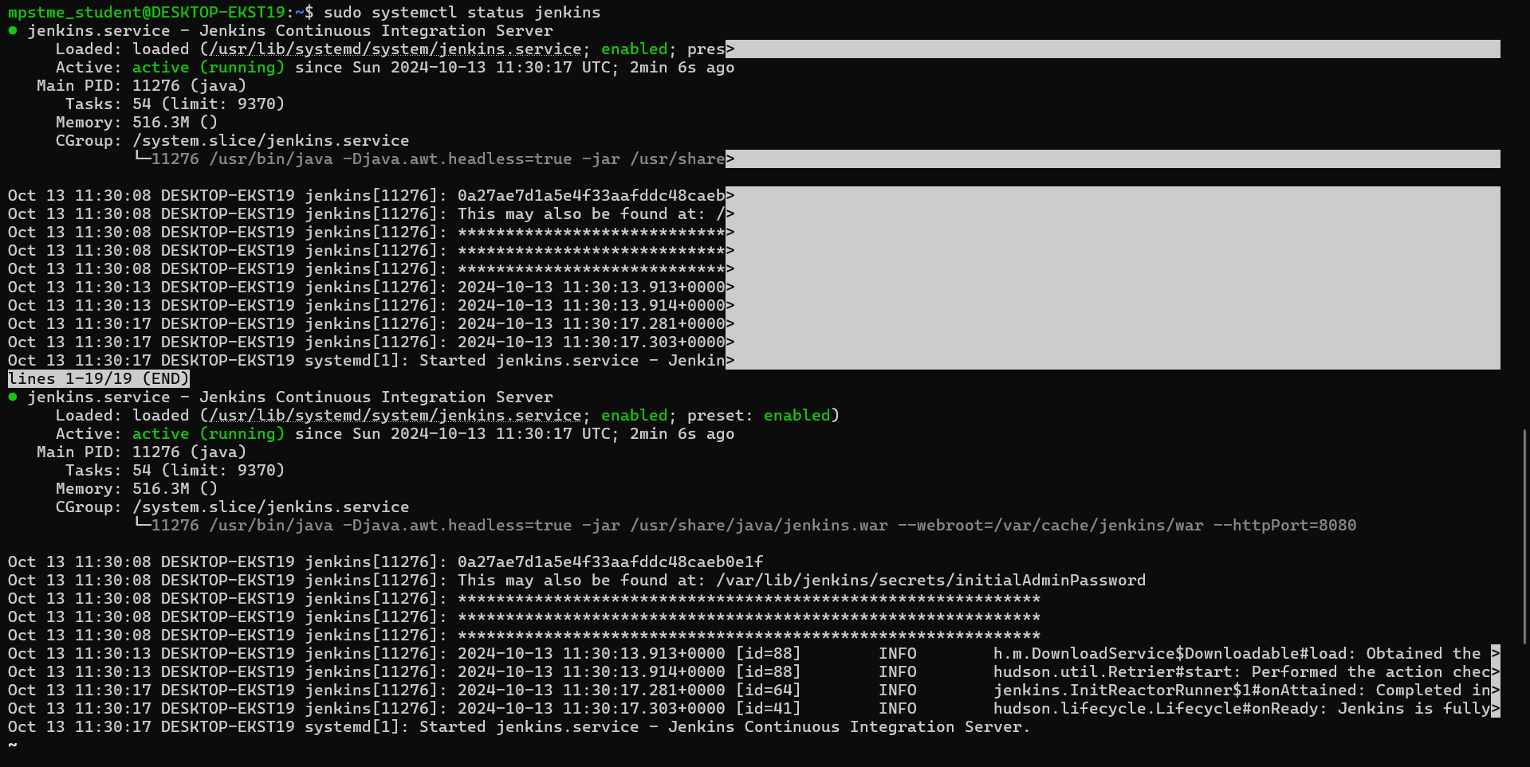

**This will also give you the location of you initial password file:**

**i.e: in this pack you will find the file open it in notepad you will be requiring this to unlock jenkins**

**Now go to browser type** [**http://localhost:8080**](http://localhost:8080) **and hit enter**

**The following page will appear :**

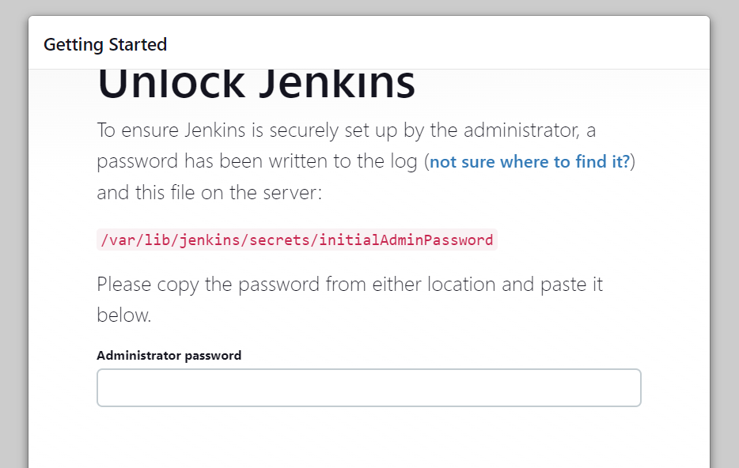

**Above when we ran the status code “sudo systemctl status jenkins” we got the password and path :**

**The below first line is the password i.e 🡪 0a27ae7d1a5e4f33aafddc48caeb0e1f**

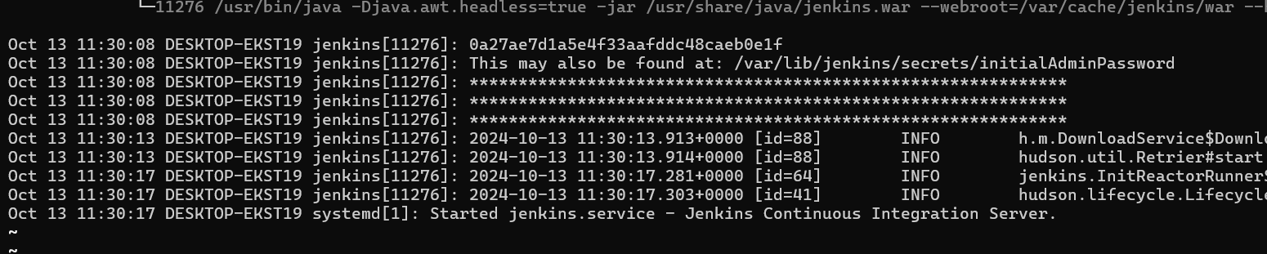

**Enter that password there then you will be redirected to the following page:**

**Select install suggested plugins:**

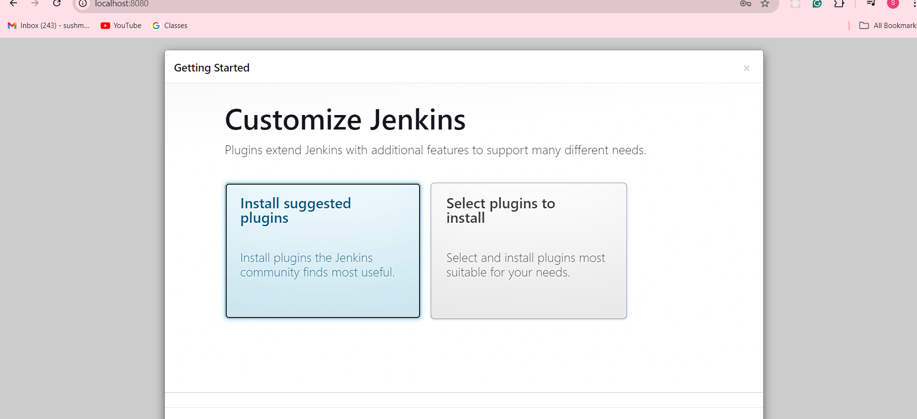

**Installation begins:**

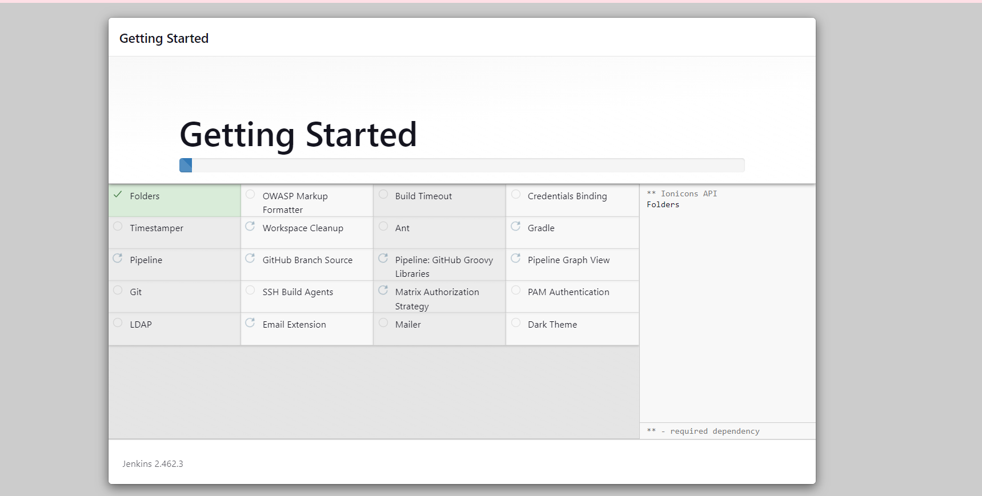

**After completion this page will appear :**

**Create you first admin user and continue:**

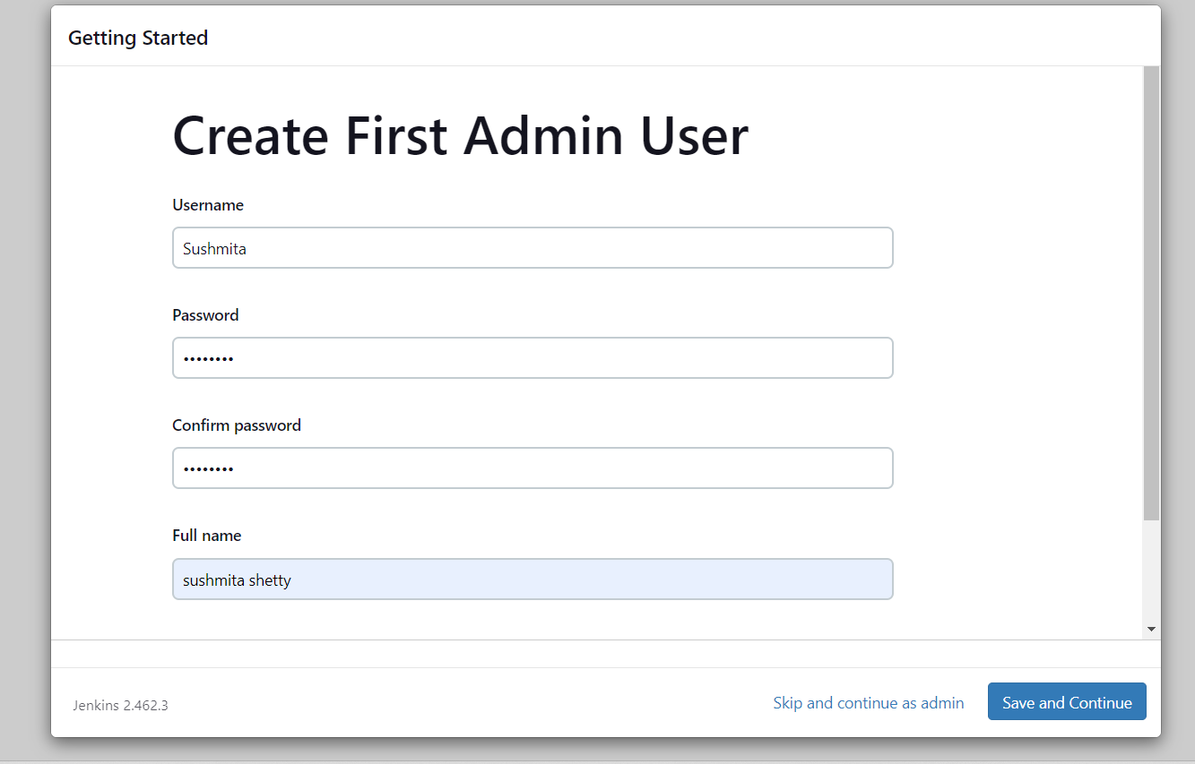

**Save and finish:**

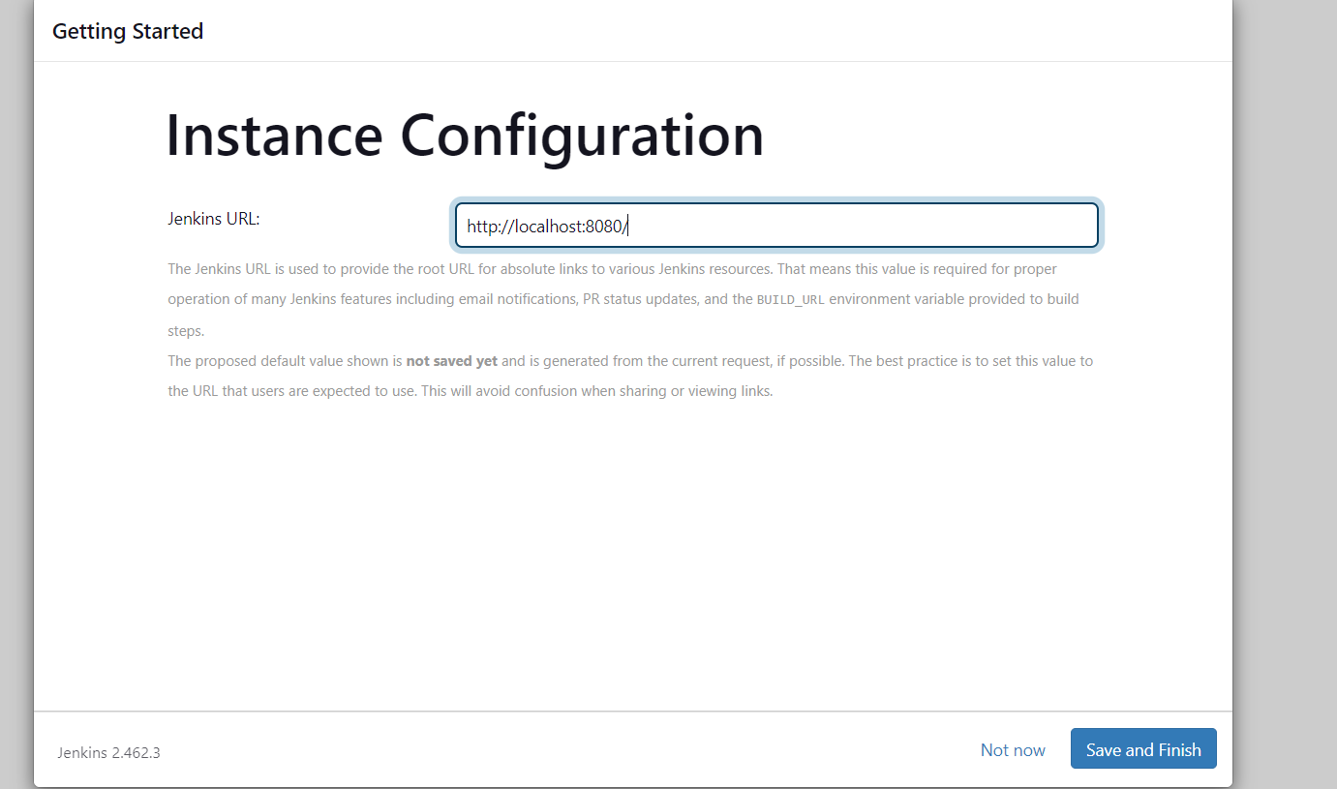

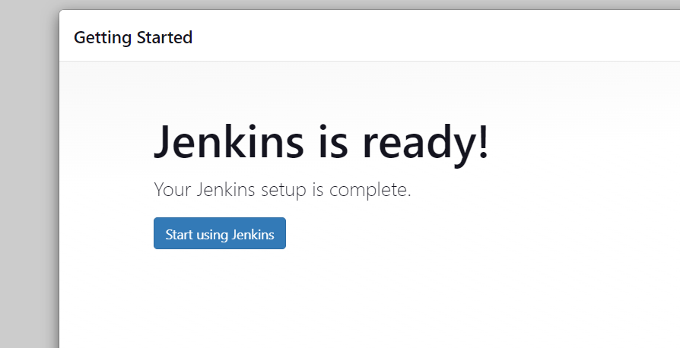

**Once installation is done,open Jenkins dashboard using** [**http://localhost:8080**](http://localhost:8080) **address.:**

**Click start using Jenkins you will be redirected to your dashboard :**

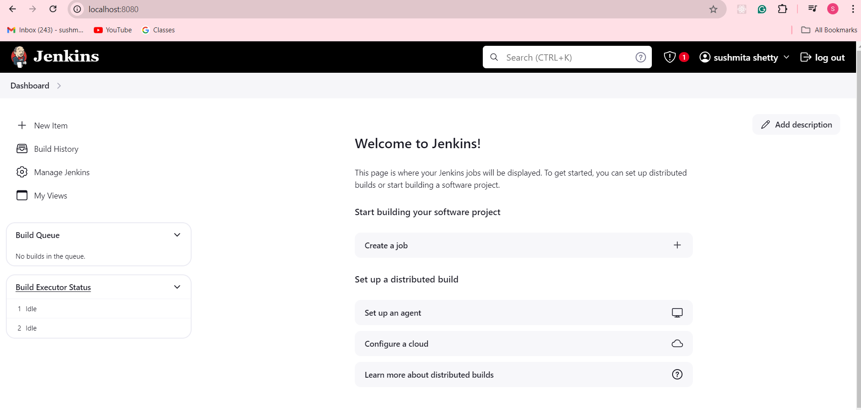

**DONE WITH PRACTICAL 6 Installation and Configuration of Jenkins**

**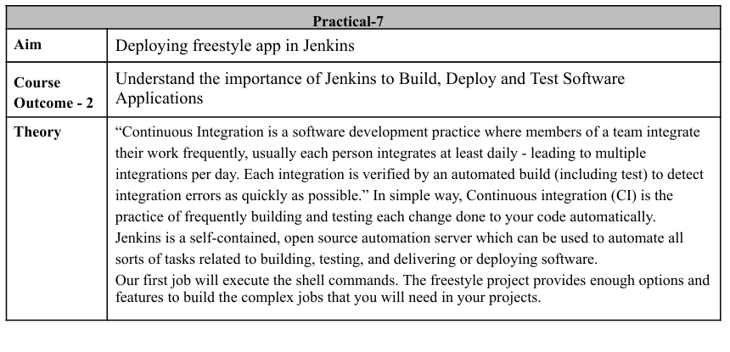  
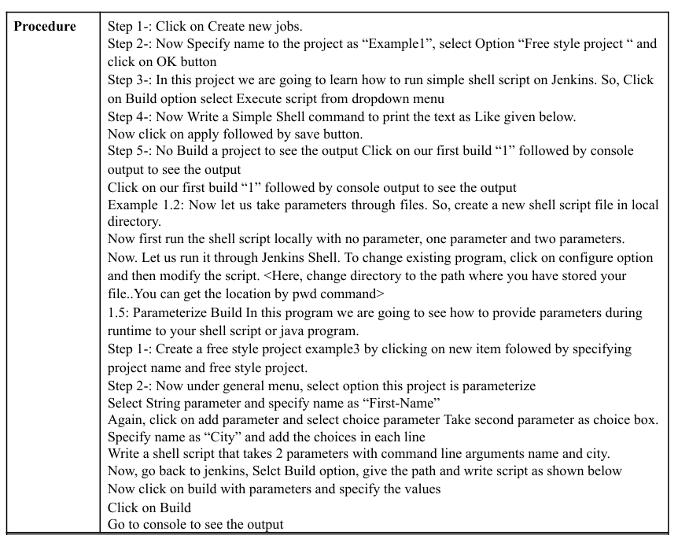**

**Part 1: Create a Simple Freestyle Job and Run a Shell Command**

**STEP 1 :** **Click on Create new jobs.**

**1st : click on new item in dashboard**

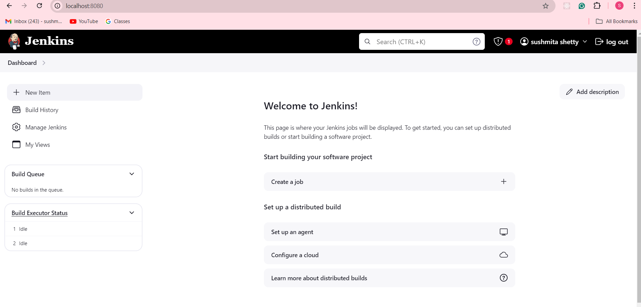

**Step 2: Now Specify a name to the project as “Example1” , select option “Freestyle project“ and click on the OK button**

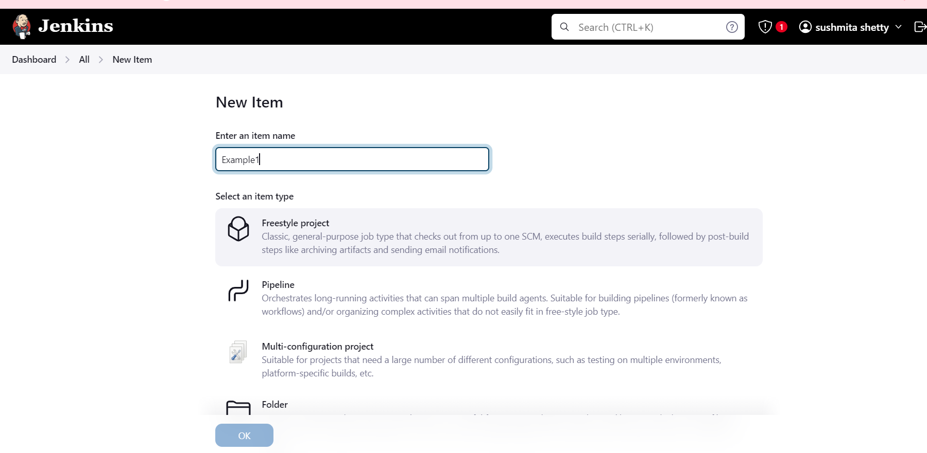

**Step3-: In this project, we are going to learn how to run a simple shell script on Jenkins. So, Click on Build option and select Execute script/shell from the dropdown menu**

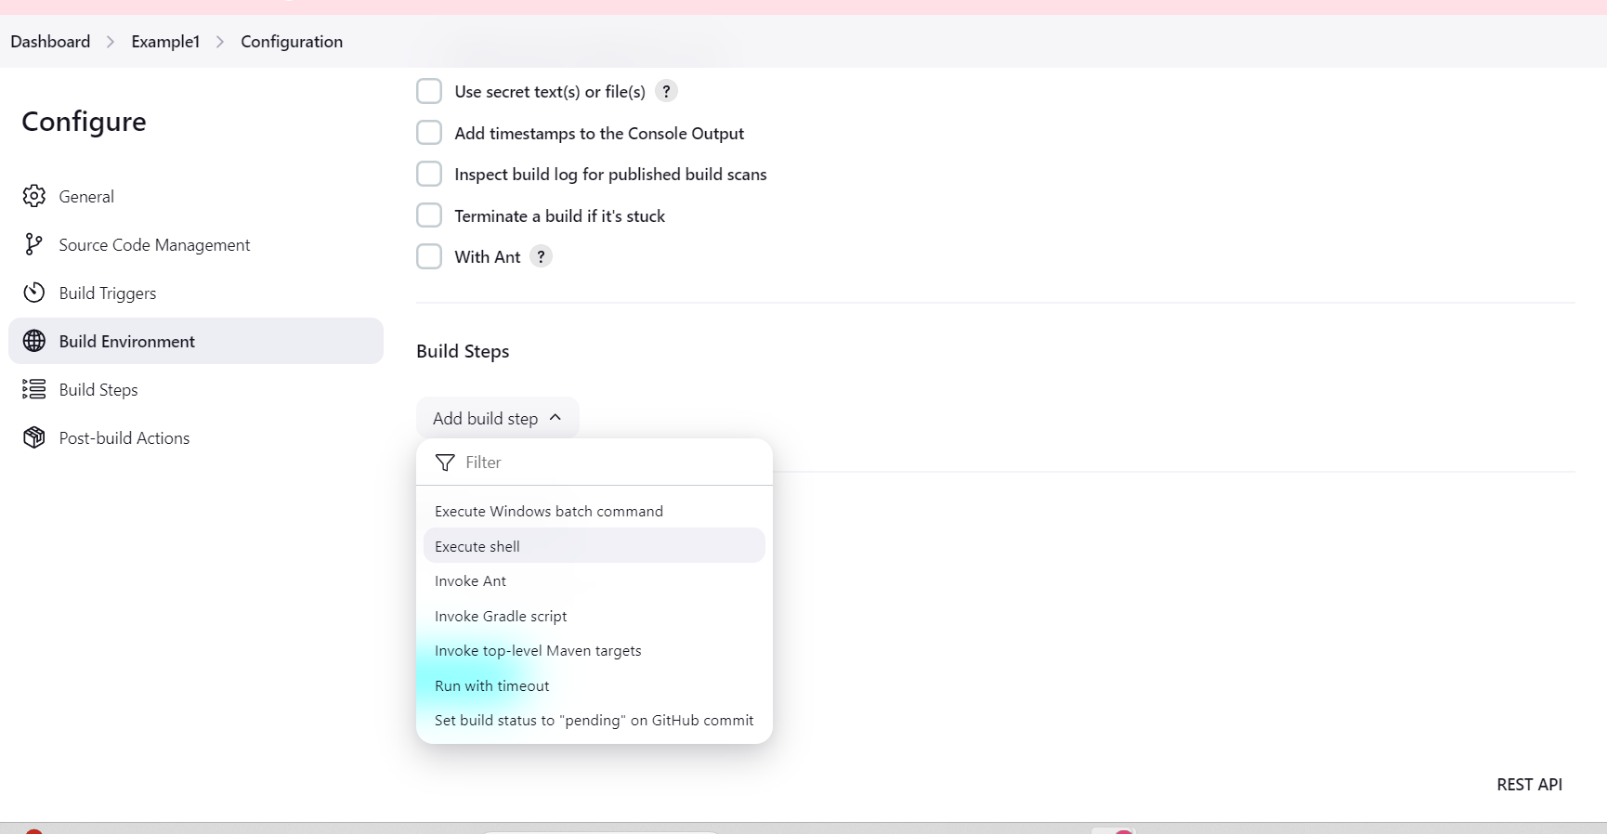

**Step4-: Now Write a Simple Shell command to print the text. then click on apply followed by save button.**

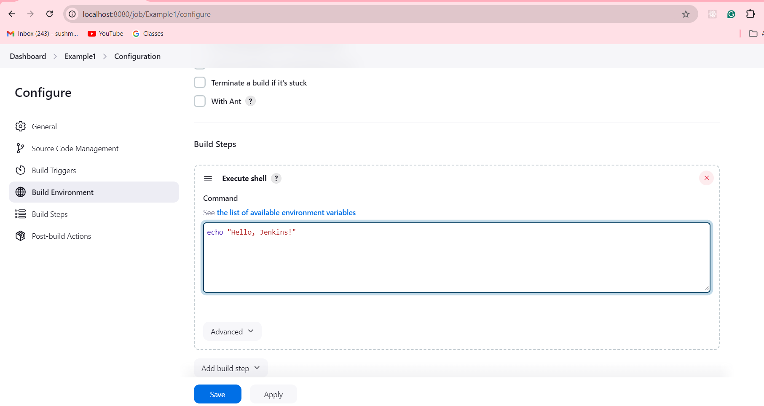

**Step5-: Now Build a project to see the output**

**After saving, click Build Now on the project’s dashboard.**

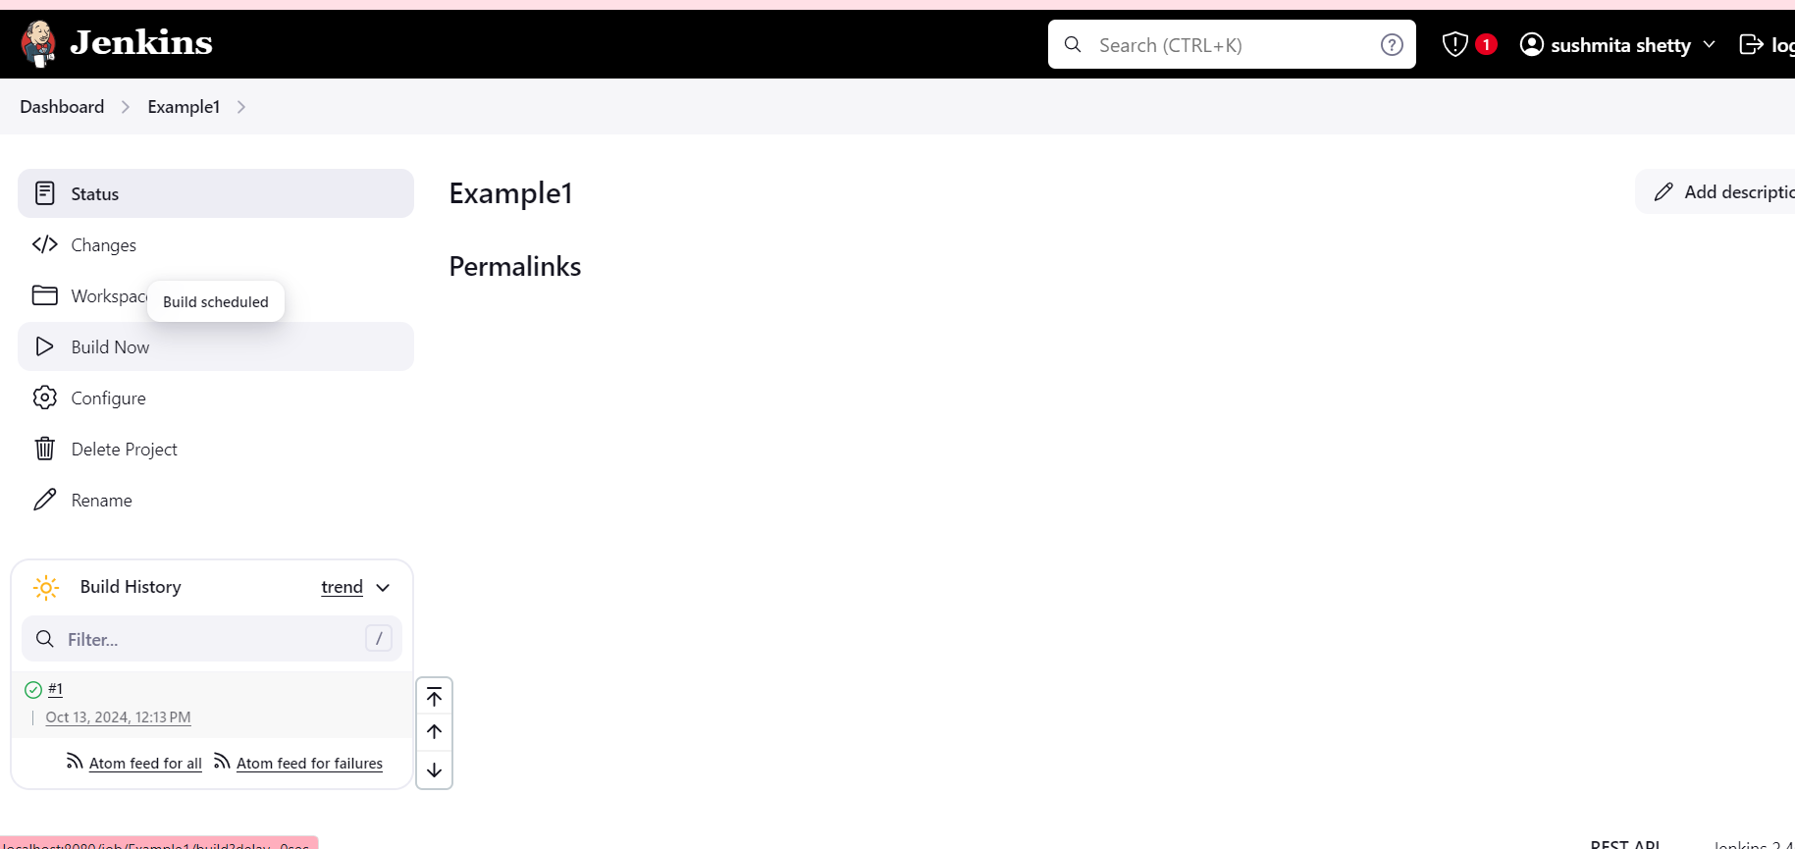

**Check the output by clicking on the build number (e.g., #1) and then Console Output to see the result.**

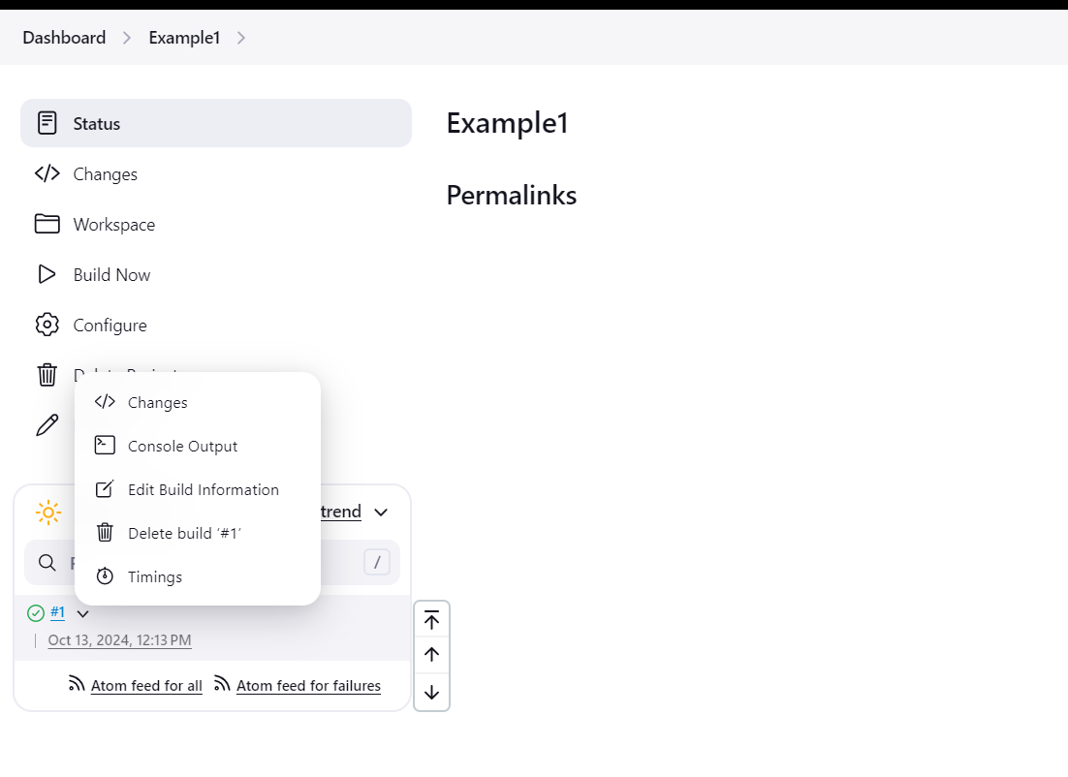

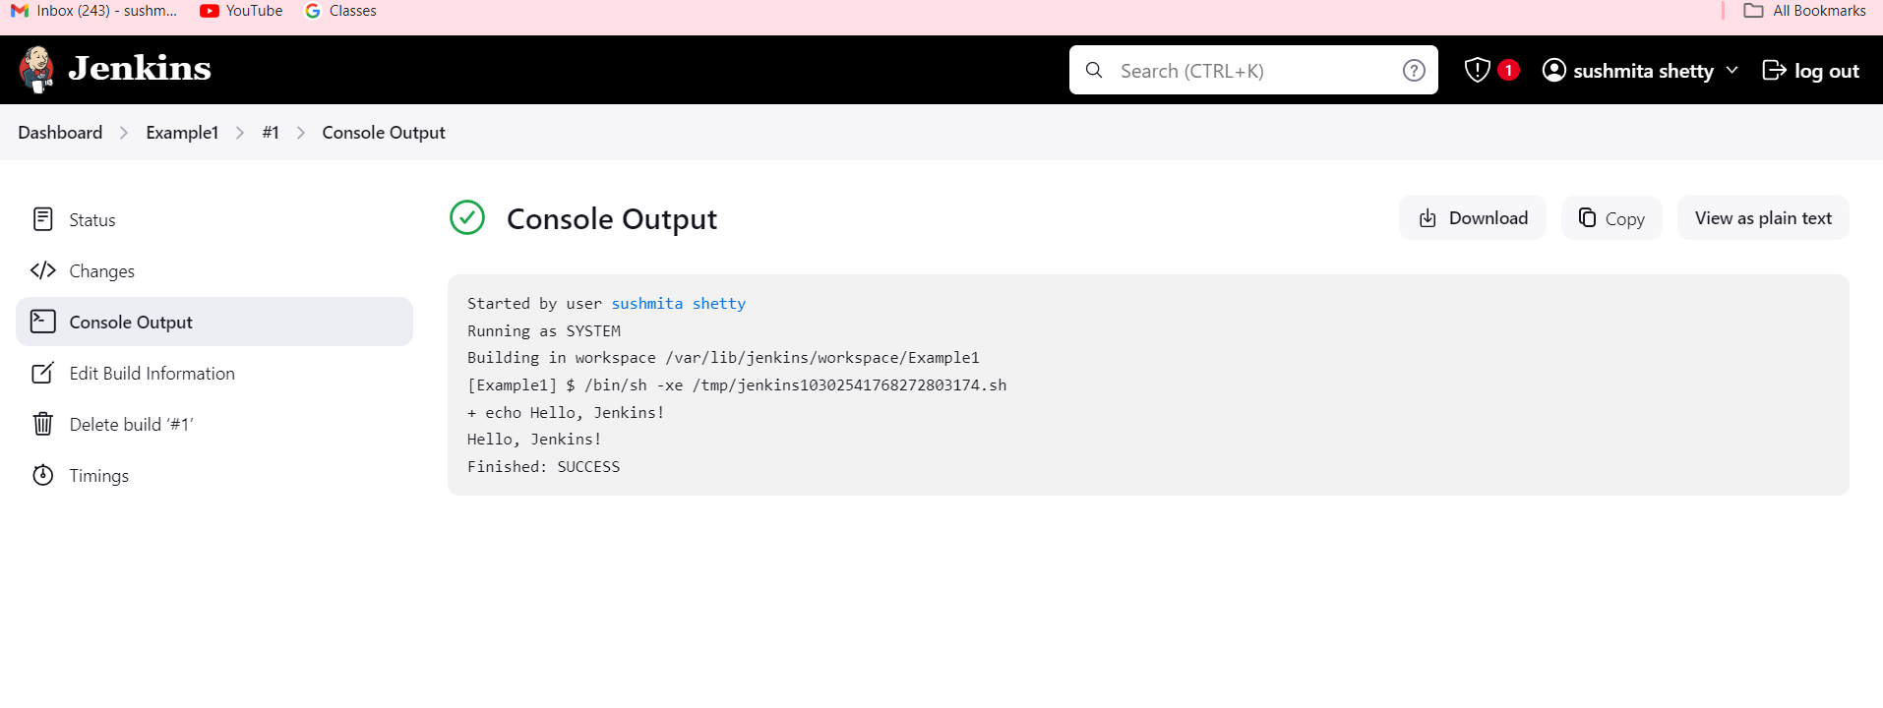

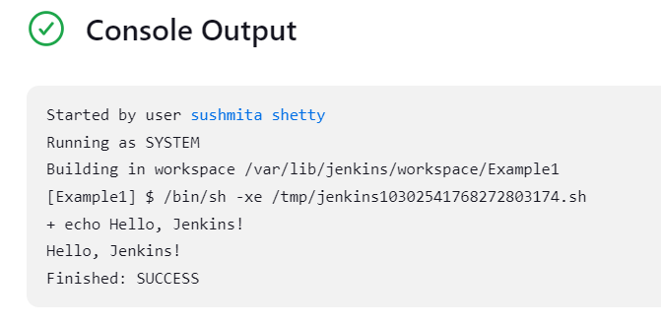

**Part 2: Parameterizing a Build in Jenkins**

**Example1.2: Now let us take parameters through files. So, create a new shell script file in the local directory. Now first run the shell script locally with no parameter,one parameter, and two parameters. Now Let us run it through Jenkins Shell.**

**Create a Shell Script Locally:**

* **Open a text editor (e.g., Notepad++ or Visual Studio Code) and create a new file called example.sh.**

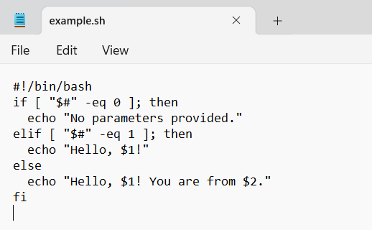

**Add the following code to the shell script:**

**#!/bin/bash**

**if [ "$#" -eq 0 ]; then**

**echo "No parameters provided."**

**elif [ "$#" -eq 1 ]; then**

**echo "Hello, $1!"**

**else**

**echo "Hello, $1! You are from $2."**

**fi # Corrected from 'Fi' to 'fi'**

**Or**

**Create the example.sh file using terminal only :**

**1st : give the path**



**2nd : run the below command this will open a terminal paste the above given code there.**

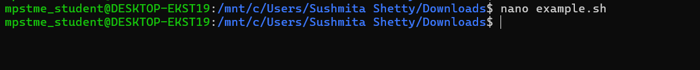

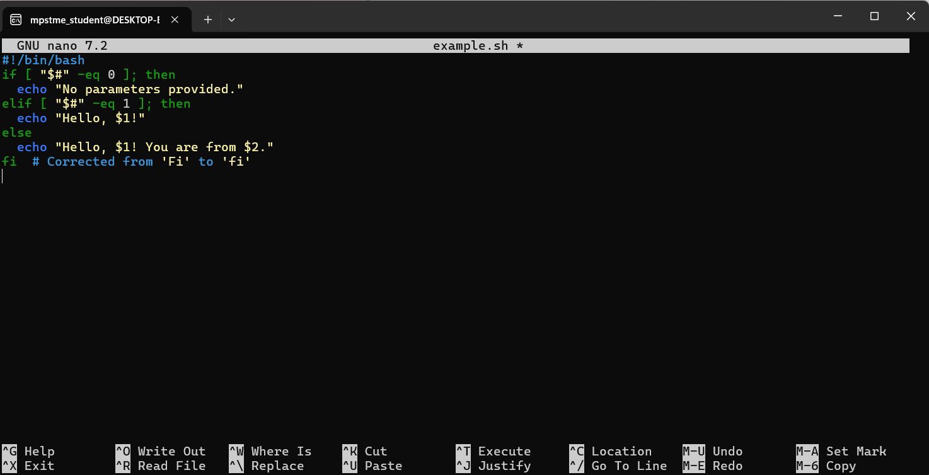

**Save the file by pressing CTRL + X, then Y to confirm, and press Enter.**

**THEN EXECUTE :**



**AFTER THAT LETS RUN ONE BY ONE**

**1ST: No PARAMETER :**

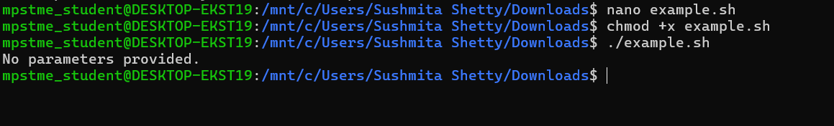

**2ND : ONE PARAMETER**

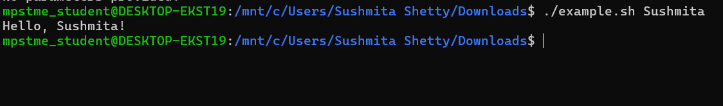

**3rd : two parameter:**

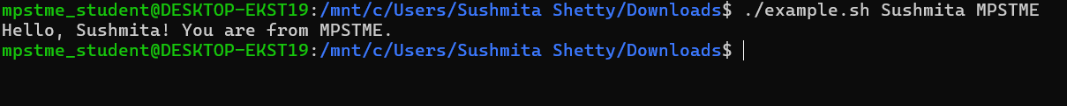

**We have succesfullt executed the shell script locally with no parameter , one parameter and two parameters.**

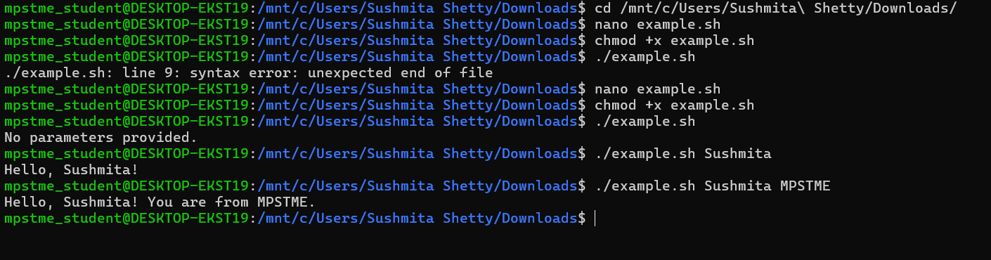

**Part 3 : Parameterize the Build and Pass Parameters to the Shell Script**

**Parameterize Build : In this program we are going to see how to provide parameters during runtime to your shell script or java program.**

**Step1-: Create a freestyle project example3 by clicking on new item followed by specifying project name and freestyle project.**

Create a New Freestyle Project:

* Go to Jenkins.
* Click New Item.

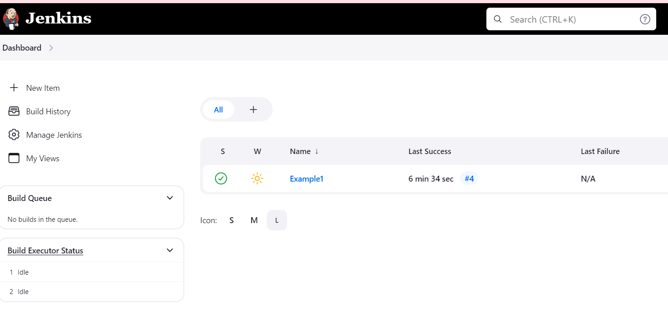

* Provide a name like Example3.
* Select Freestyle Project and click OK.

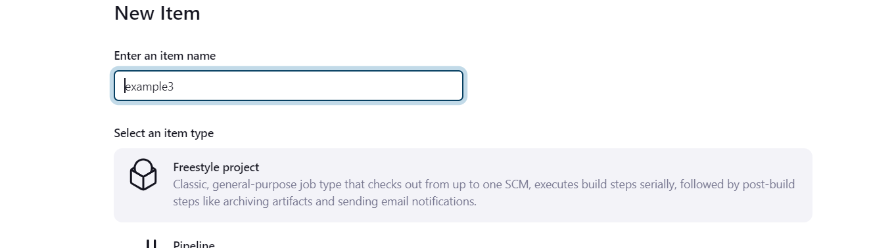

**Step2-:Now under general menu , select option this project is parameterize**

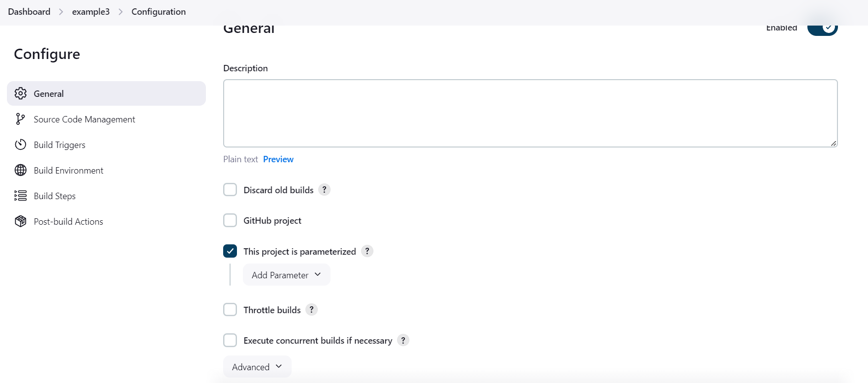

**Select String parameter and specify name as “First-Name”**

* Click Add Parameter and select String Parameter.
* Name the parameter First-Name.

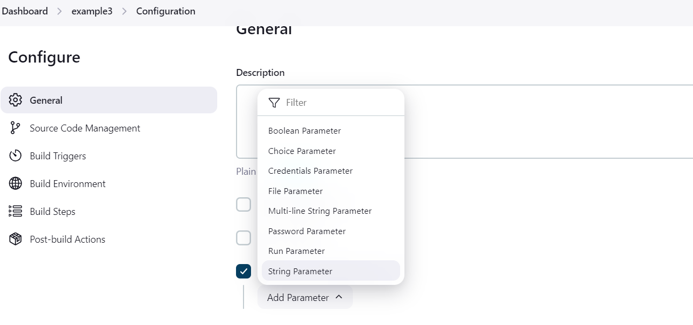

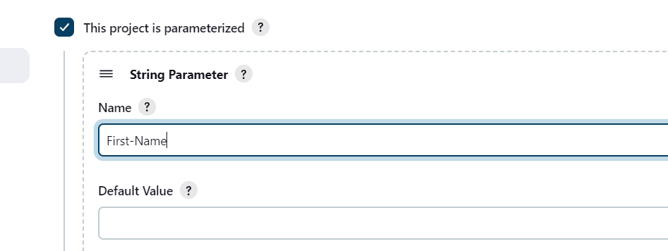

Scroll down and again click on Add another parameter by clicking **Add Parameter** → **Choice Parameter**.

Name the second parameter City and add choices like "New York", "Los Angeles", "San Francisco" (one per line).

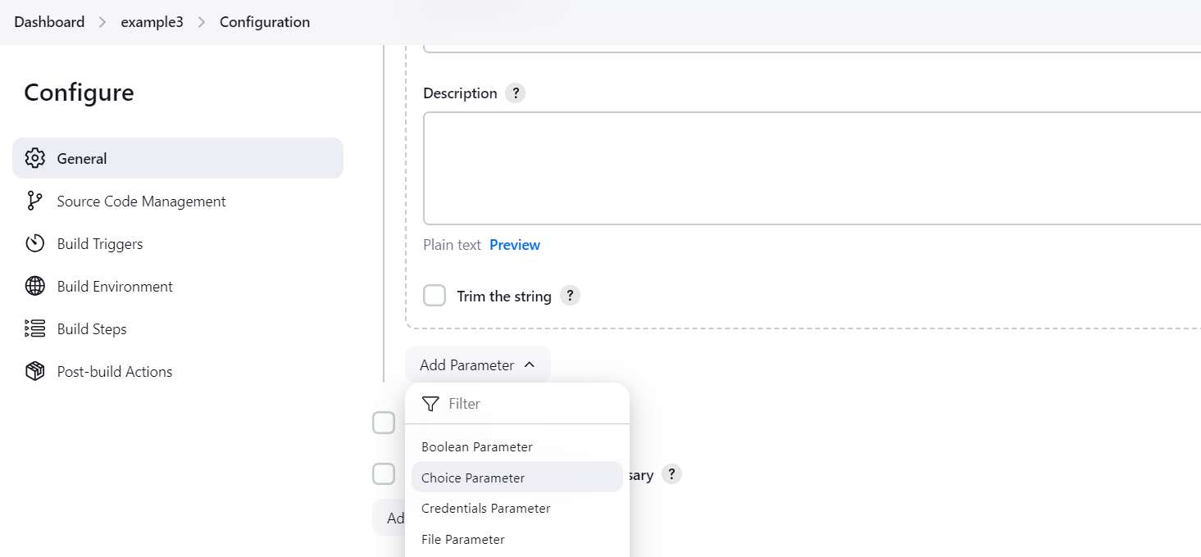

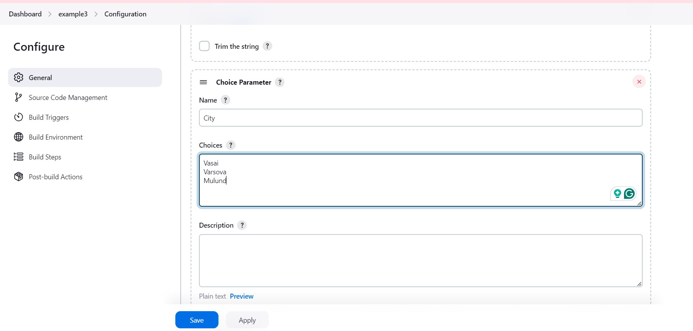

Scroll down to build: to do the following task

**Write a shell script that takes 2 parameters with command line arguments name and city.**

Add Build Steps:

* Scroll down to the “Build” section.
* Click on “Add build step” and select “Execute shell.”

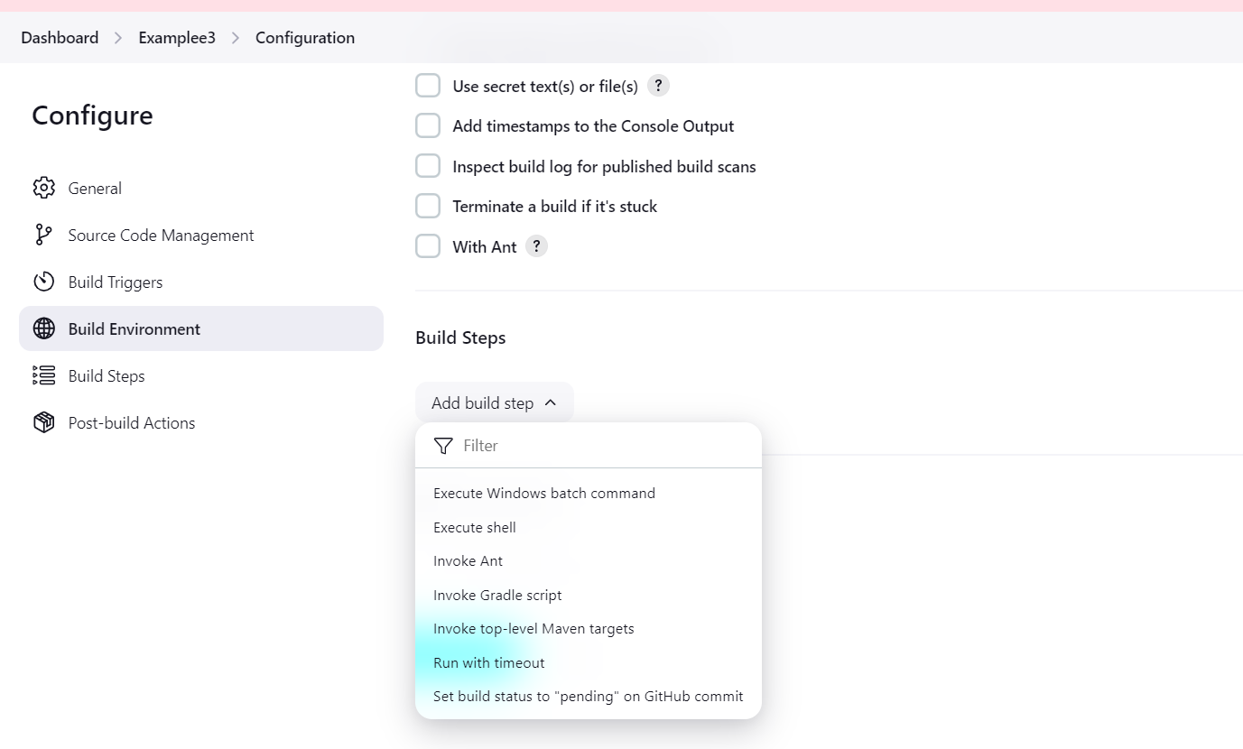

* In the command box, enter the following command to run your script and pass the parameters:

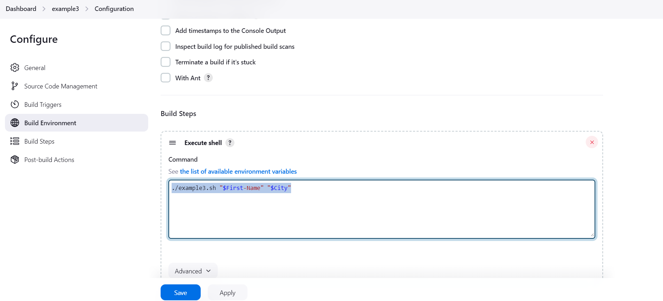

Command:

./example3.sh "$First-Name" "$City" //Examplee3.sh is the file name you created with extention as .sh

**Scroll down apply and click on “Save.”**

**Build the Project**

1. **Select Your Project:**
   * **Click on your project name (e.g., example3).**
2. **Build with Parameters:**
   * **Click on “Build with Parameters.”**

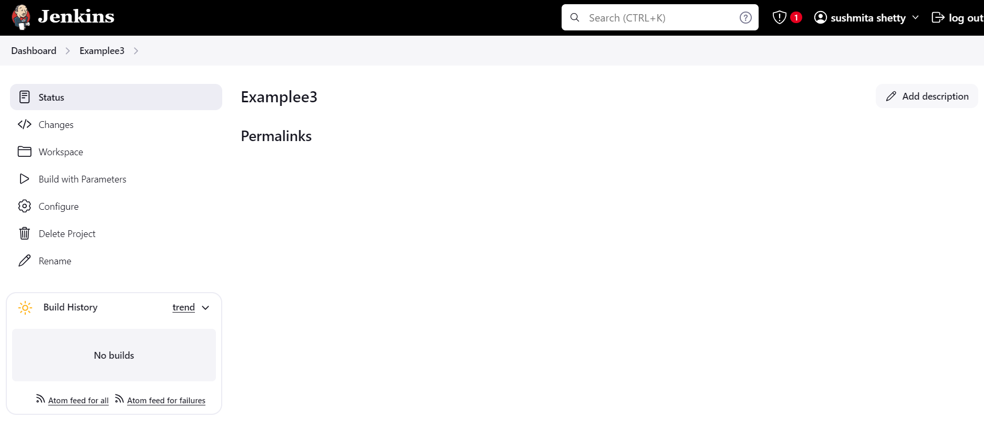

* + **In the form that appears, fill in the values for First-Name and City. For example:**
    - **First-Name: Alice**
    - **City: New York**

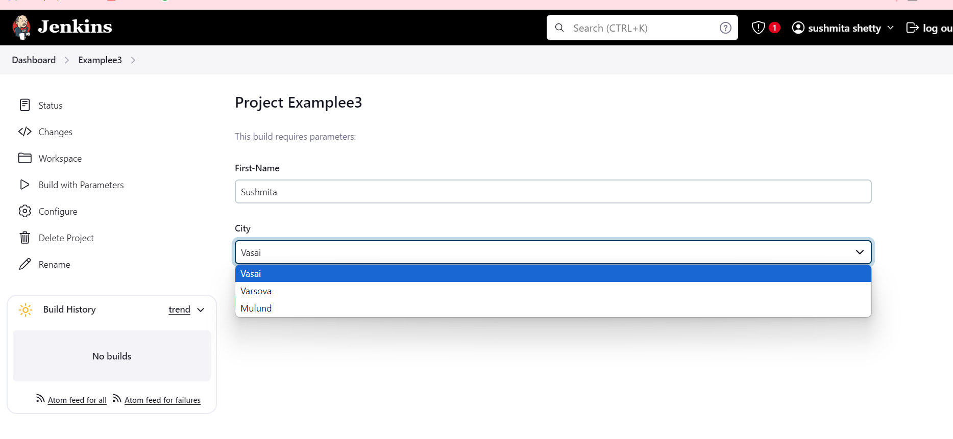

* + **Click on “Build.”**

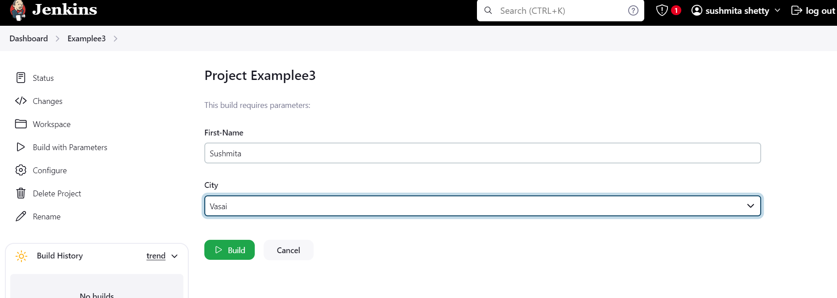

**Step 4: View Console Output**

1. **After the build completes, click on the build number (e.g., #1) on the project page.**
2. **Click on “Console Output” to see the results of your script execution.**

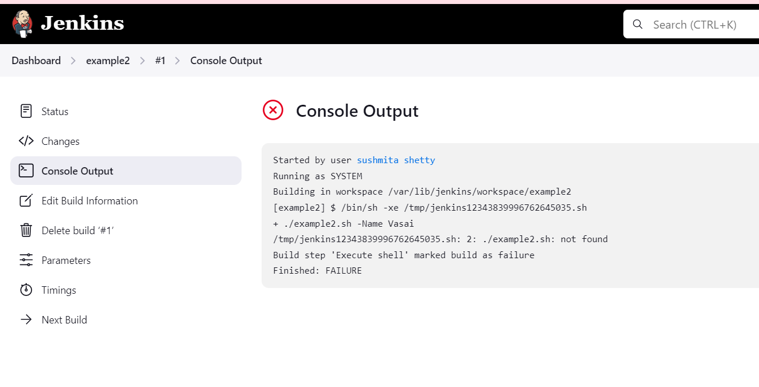

**Failed**

**Now while I try to build its getting failed**

**Solution:**

**1: Use sudo to Edit the File**

1. **Open Terminal.**
2. **Use sudo to Edit the File:**

sudo nano /var/lib/jenkins/workspace/example2/example2.sh



1. **Enter Your Script**: Replace any existing content with the following:

#!/bin/bash

echo "Hello, $1 from $2!"

1. **Save and Exit**:

* Press Ctrl + X, then Y to confirm changes, and Enter to exit.

1. **Set Permissions**: If necessary, you may also need to set the executable permissions using:

sudo chmod +x /var/lib/jenkins/workspace/example2/example2.sh



1. **Verify the Script** Before proceeding to Jenkins, let’s confirm that the script is correctly set up.

cat /var/lib/jenkins/workspace/example2/example2.sh

**Now go to the jenkin dashboard click on the failed job i.e example3 select that**

**Go to configure on left side:**

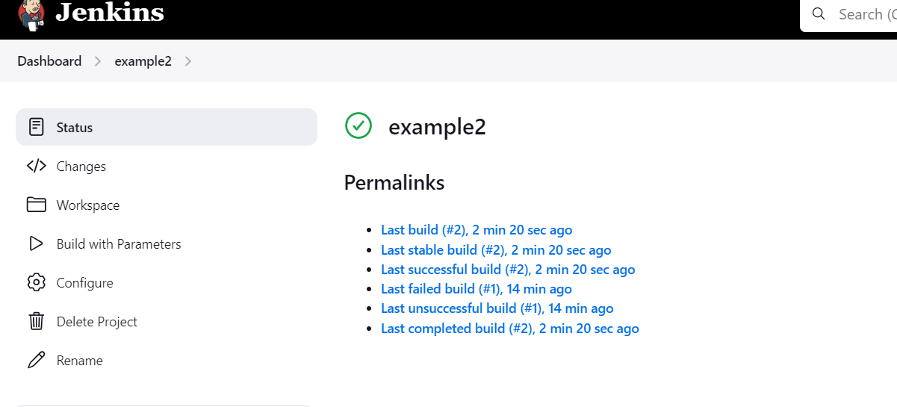

Again check every parameters:

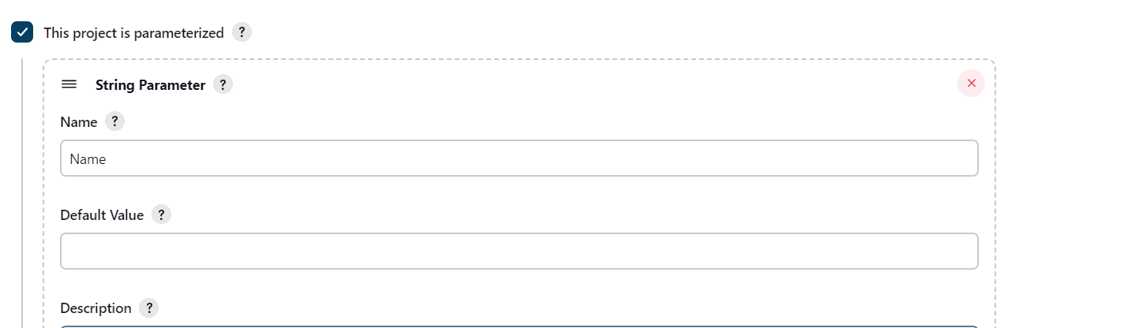

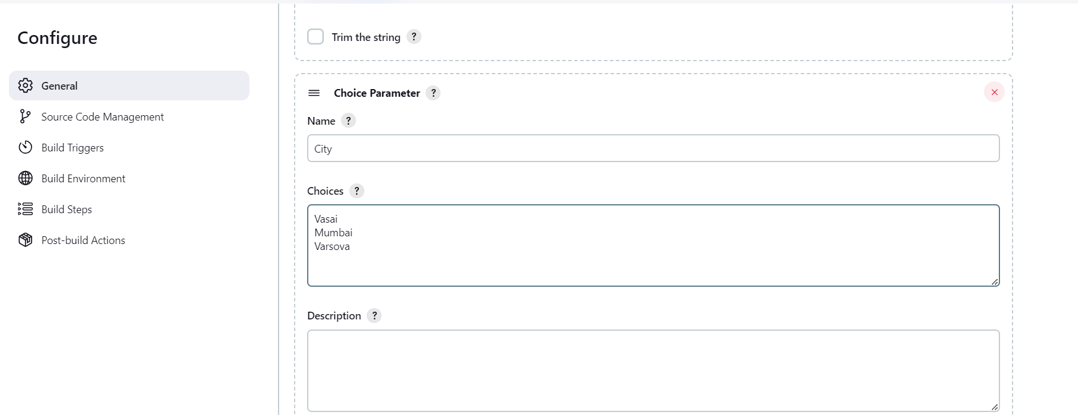

./example2.sh "$Name" "$City"

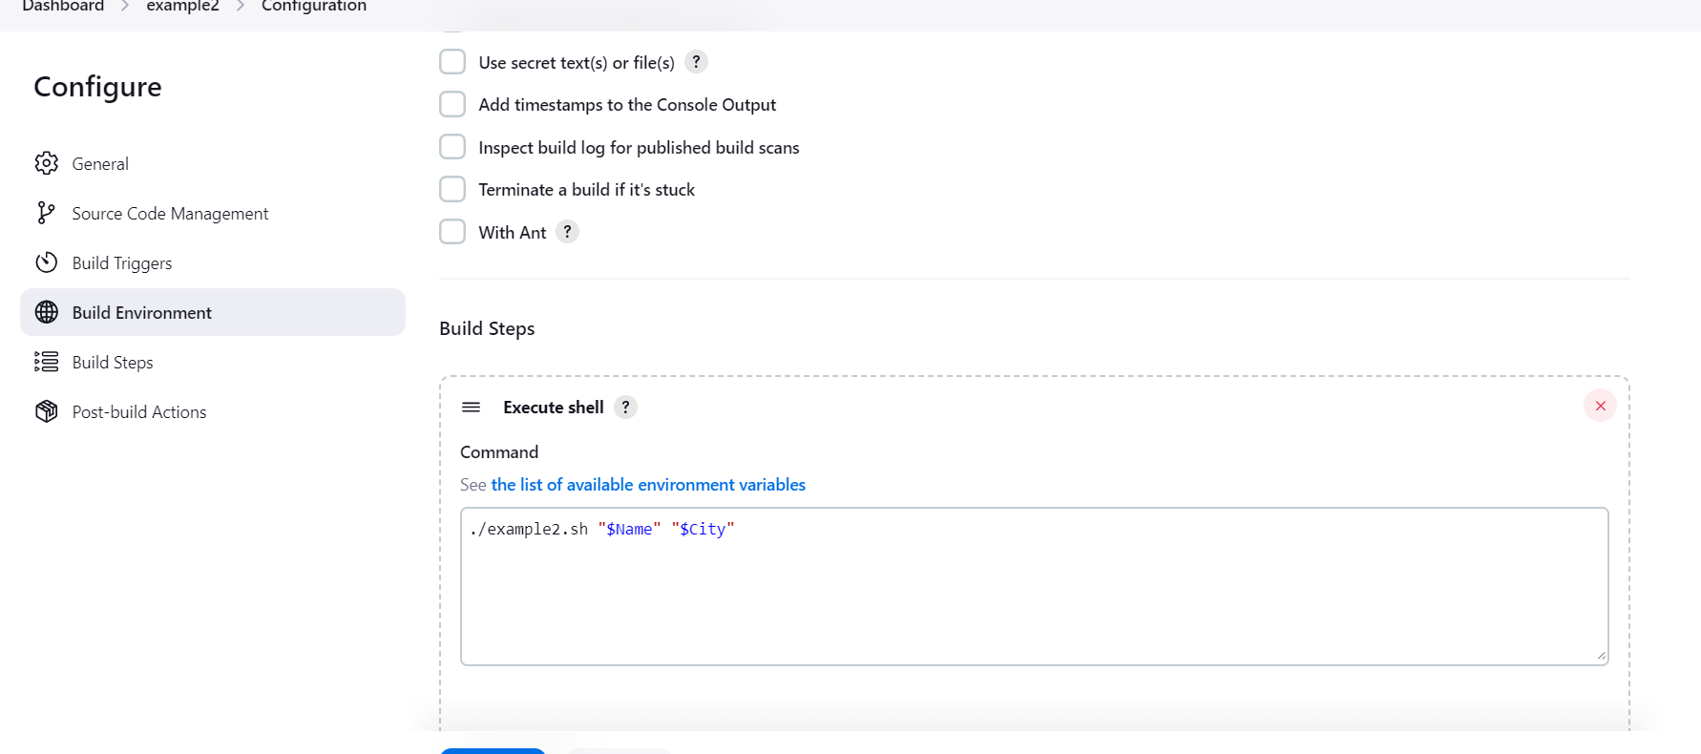

Then click on save :

Build is successful now:

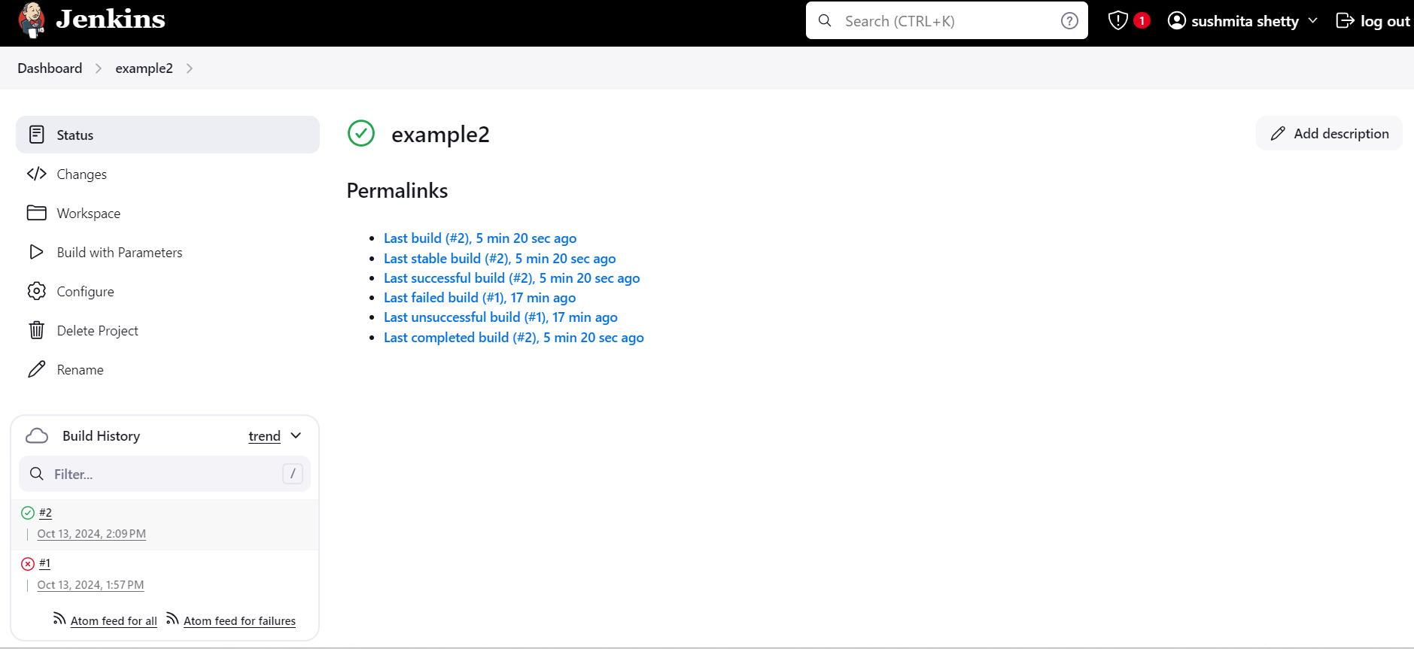

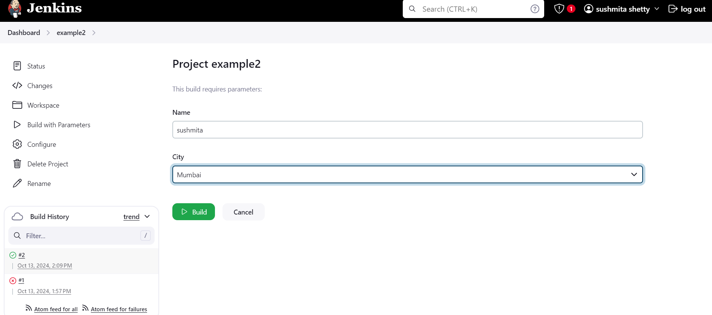

Check the console:

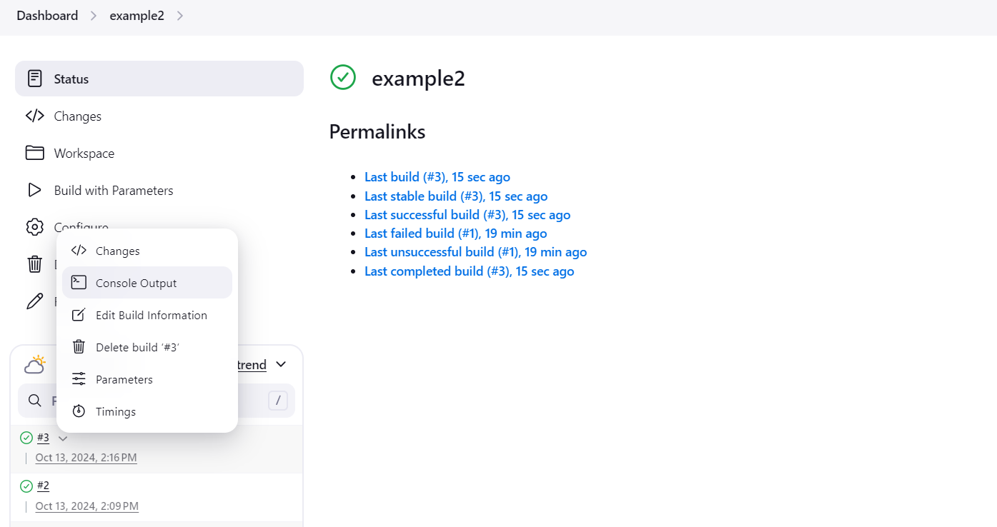

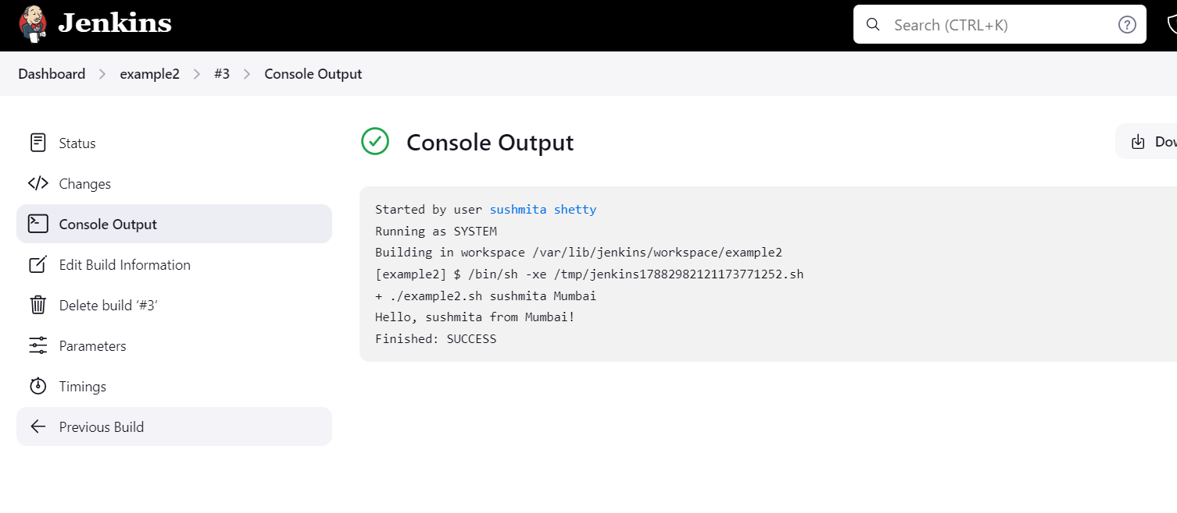

Done Jenkins